Anisha Aggarwal

CS 161

**Flowchart – “Word Guessing Game”**

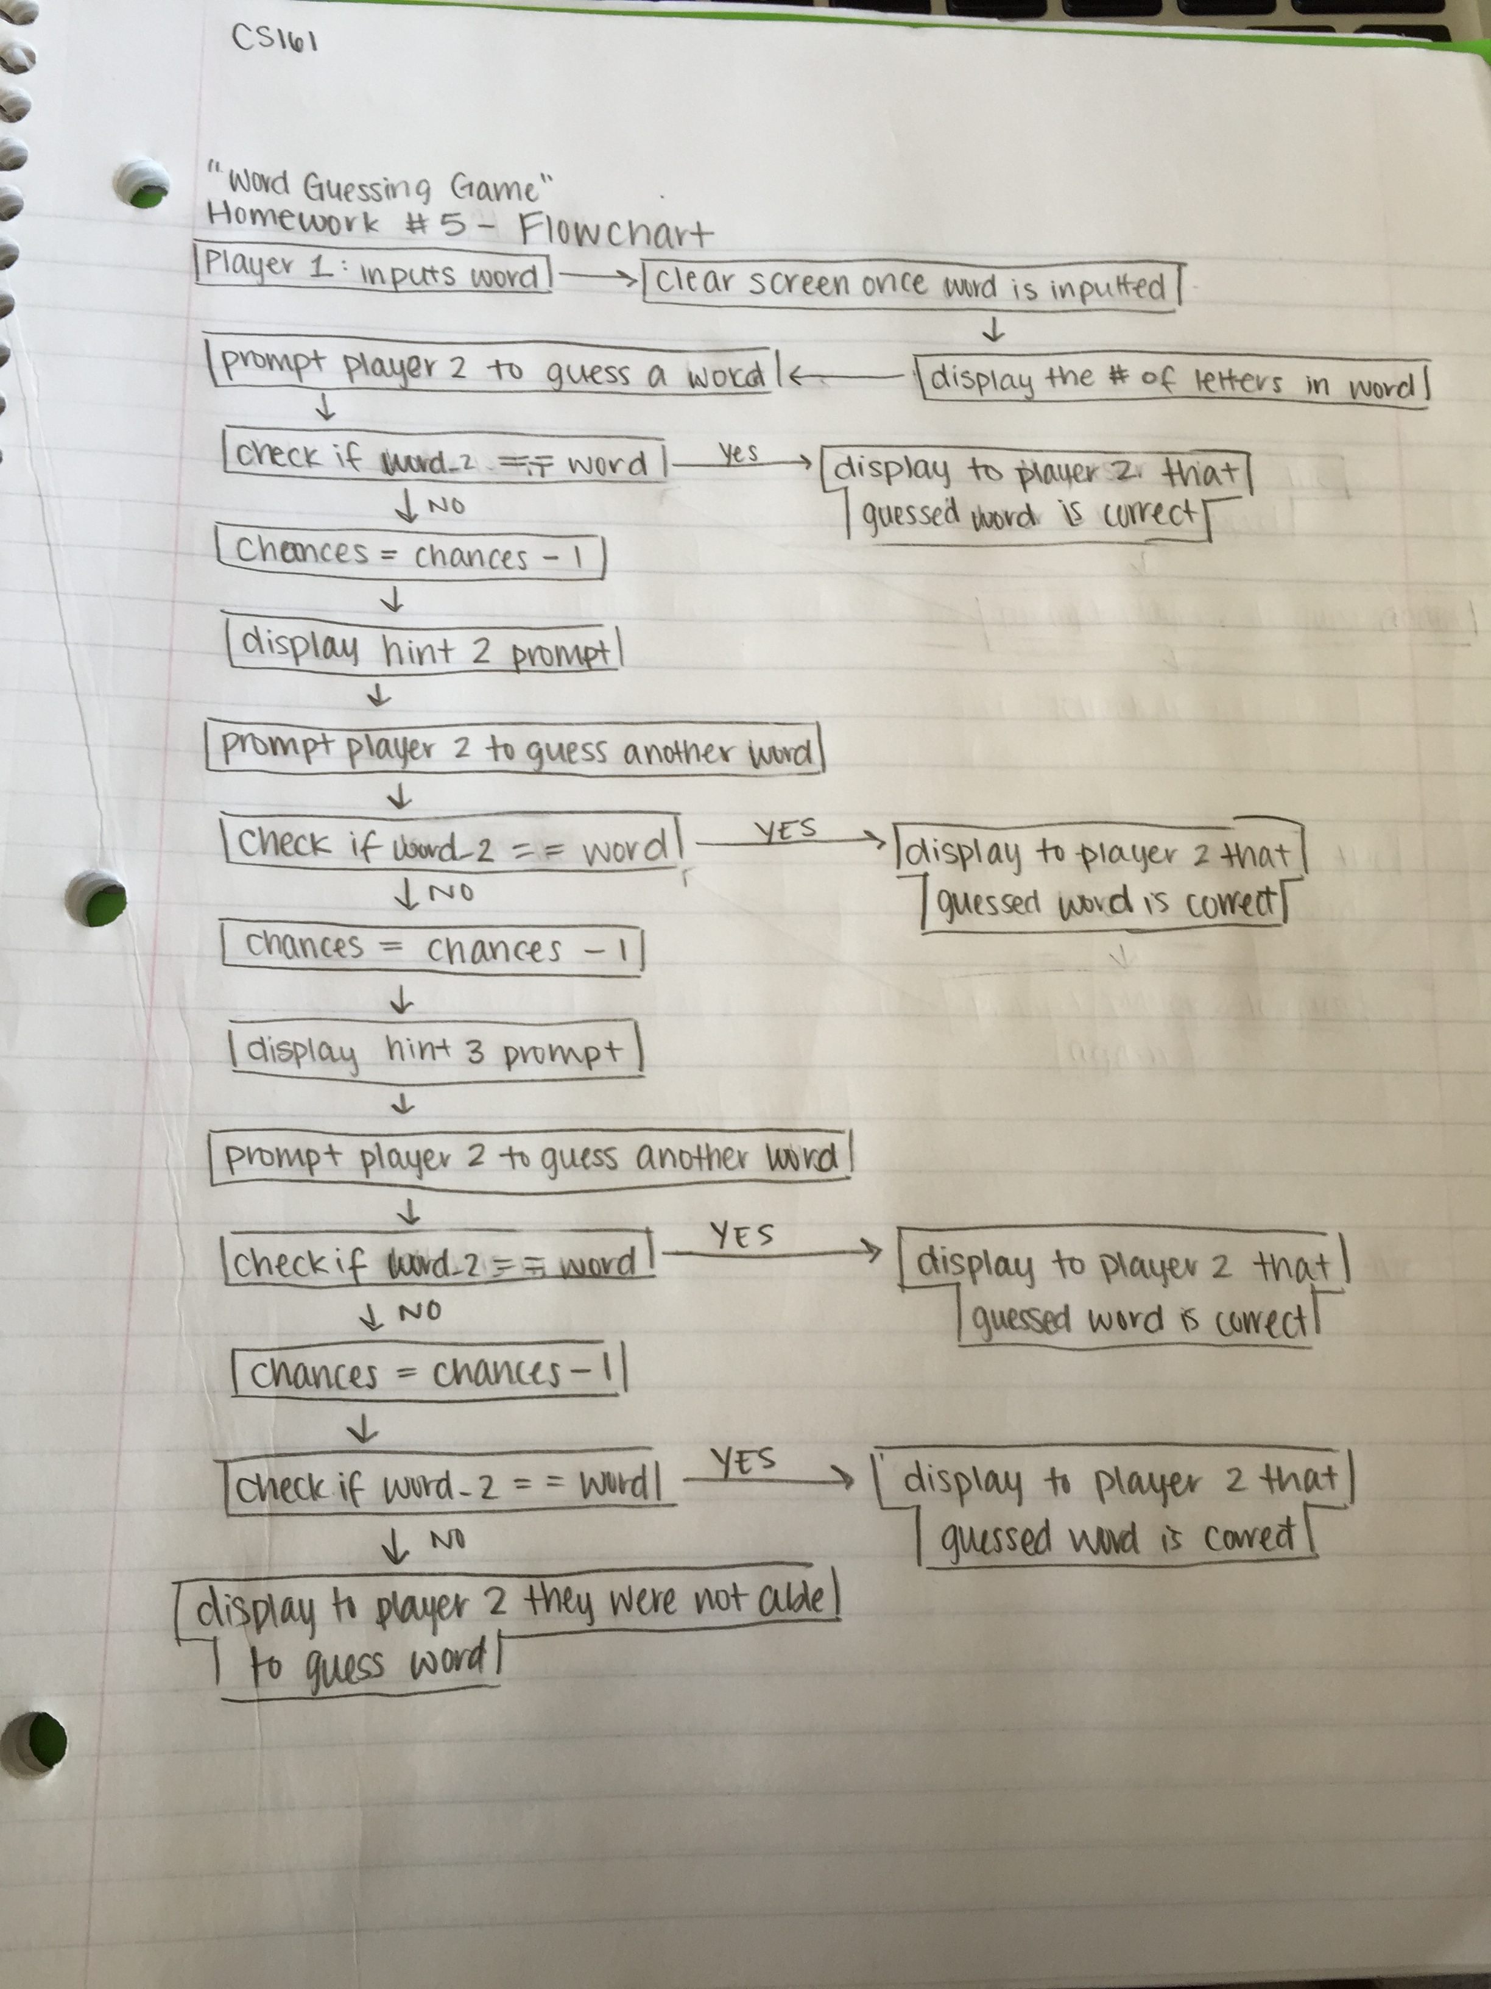

**Review Questions (3-12)**

3. Which of the following is *not* a step that must occur with every correctly working loop? c.

4. The statements executed within a loop are known collectively as the loop body.

5. A counter keeps track of the number of times an event has occurred.

6. Adding 1 to a variable is also called incrementing it.

7. Which of the following is a definite loop? b. a loop that executes 100 times

8. Which of he following is an indefinite loop? d. none of the above

9. When you decrement a variable, you c. subtract a value from it

10. When two loops are nested, the loop that is contained by the other is the d. outer loop.

11. When loops are nested, d. none of the above.

12. Most programmers use a for loop b. when they know the exact number of times a loop will repeat.

**Programming Exercise #5**

Design the logic for a program that outputs numbers in reverse order from 25 down to 0.

for (int j = 25; j >= 0; --j)

{

cout << j << endl;

}